**FINA6281**

**Assignment1**

**(Due date July/13/2018)**

**Ying Gao**

**Jing Xu**

**Dingding Zhong**

**Qianli Zhao**

**Kunbo Yao**

**Summary of work**

We use the Black-Scholes model to calculate the values and “Greeks”, which include the delta, gamma, vega, theta, and rho, of European calls and puts with one-year maturity, six-month maturity, and at expiration. Firstly, we defined the functions of Black-Scholes model, the parameters of Black-Scholes model, and the functions used to calculate the values and the “Greeks” of calls and puts. Secondly, we input the values of different parameters. Thirdly, we wrote the results to the spreadsheet. Finally, we created the plots of the values and each “Greeks” of calls and puts in the Excel. The equations used to calculate shows as the following.

**Call & Put valuation Formula**

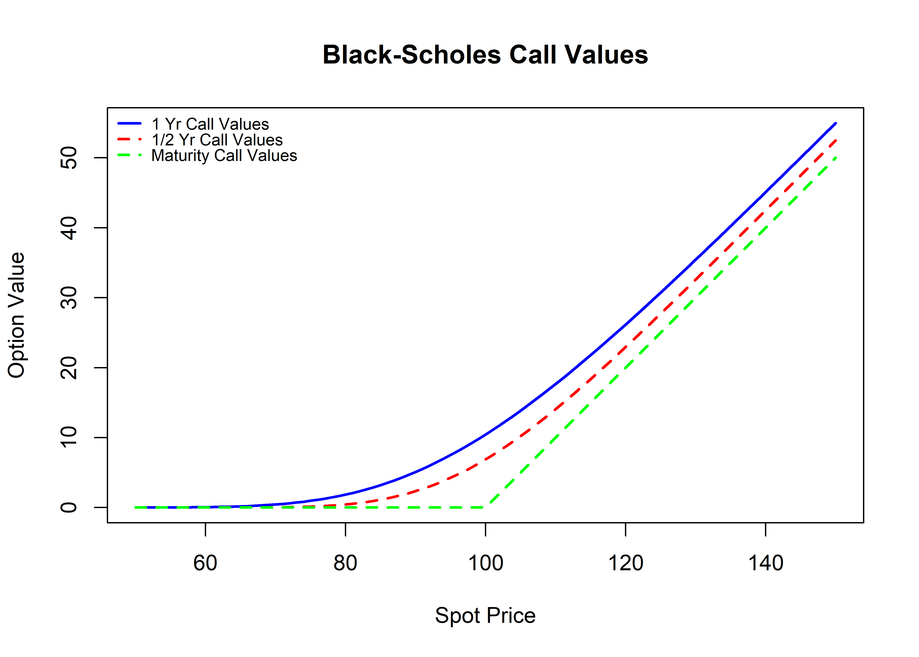

Fig. 1 Call values vs. Stock price

As the Fig. 1 shows, call values would increase as the stock price increase and the speed of increase increases as the stock price increases for one-year call and half-year call. But for the maturity call, the call values increase as the stock price goes up with the same amount only after the stock price exceeds the strike price. The values of one-year call increase at lower stock price, because it has higher probability of becoming in-the-money than the half-year call and maturity call.

Put values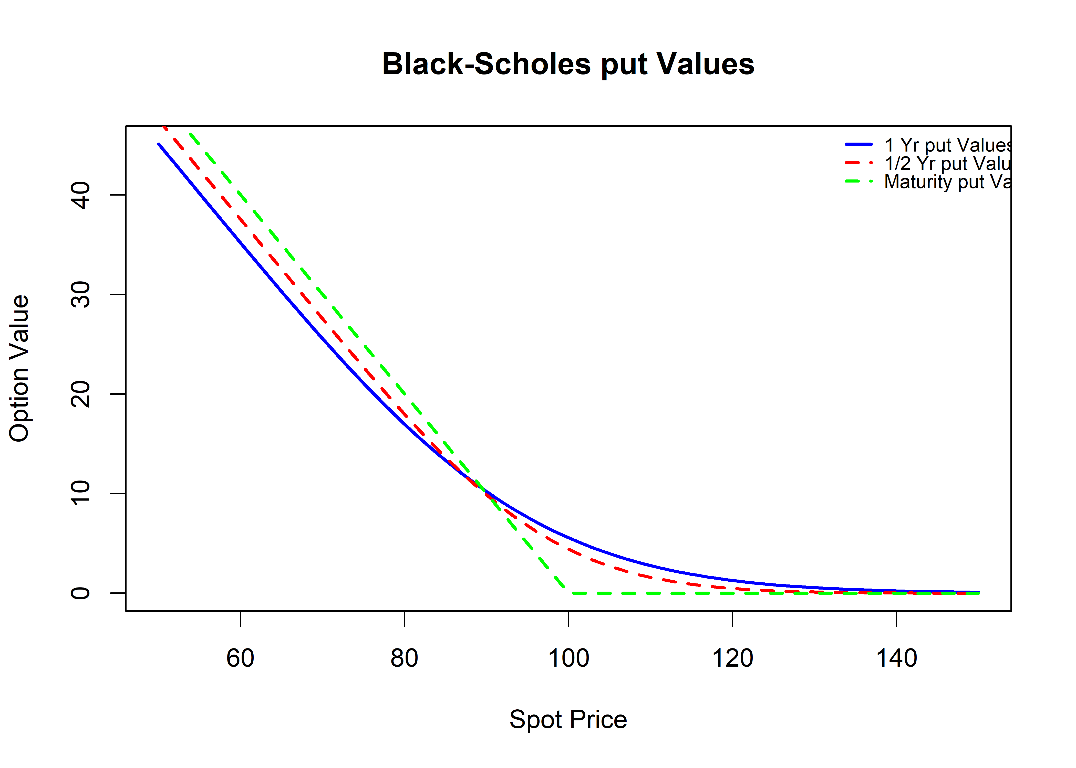

Fig. 2 Put values vs. Stock price

The Fig. 2 shows a negative relation between the put values and the stock price. It means that put values decrease as the stock price increases. The values of one-year put and half-year put decline slower and slower as the stock price increases. But the values of maturity put decrease with the same amount as the stock price increases when the maturity put is in-the-money. Additionally, we find that the line of one-year put cross over the line of half-year put. We think that this may be due to the different maturity, gamma, and delta.

**Call Delta & Put Delta**

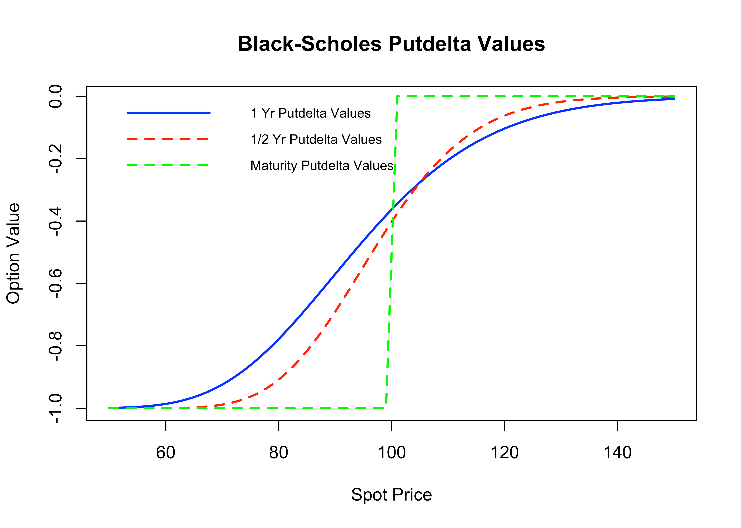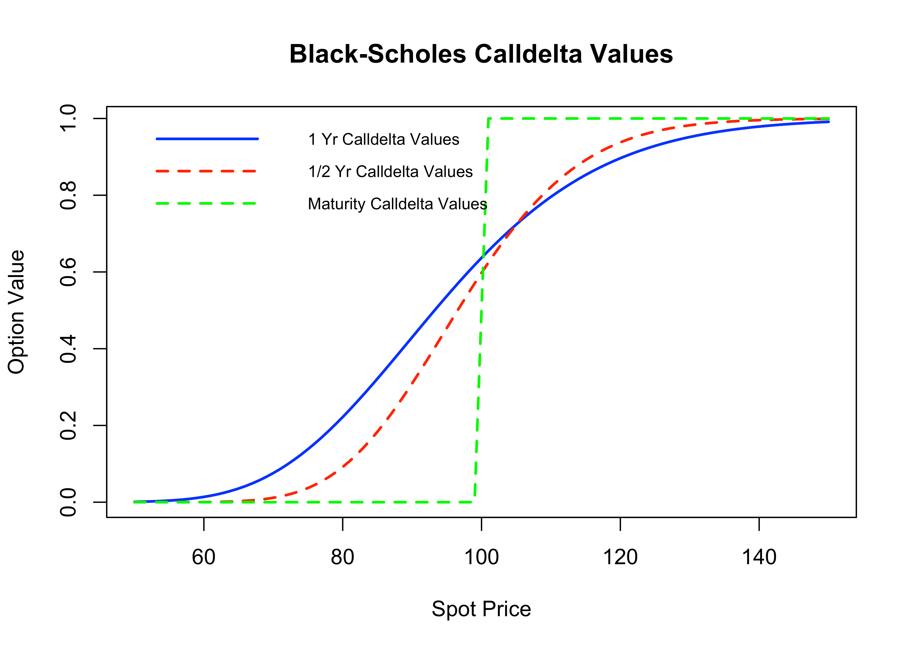

The delta of an option, , is defined as the rate of change of the option price respected to the rate of change of underlying asset price: , where  is the option price and S is underlying asset price. We next show the derivation of delta for various kinds of stock option.

For call option, higher underlying price makes the option higher option price with higher intrinsic value, therefore makes the delta of the call a positive number. If spot price higher than exercise price for a significant amount, every increase in underlying asset will make the call option making more money, so call delta will approach to 1. If spot price lower than exercise price for a significant number, the call options almost definitely losing money, then the underlying price will not impact the option’s intrinsic value and delta becomes 0. A one year option has longer maturity so it has more time and needs stronger evidence to make sure the result, so its call delta reaches to 1 or 0 later than other 2 options.

For put option, higher underlying price makes the option lower intrinsic value and lower option price so the put delta is negative number. Other aspects are same as call options.

For both kinds of options, long maturity option has less sensitive delta than short term option.

**Call Gamma & Put Gamma**

)

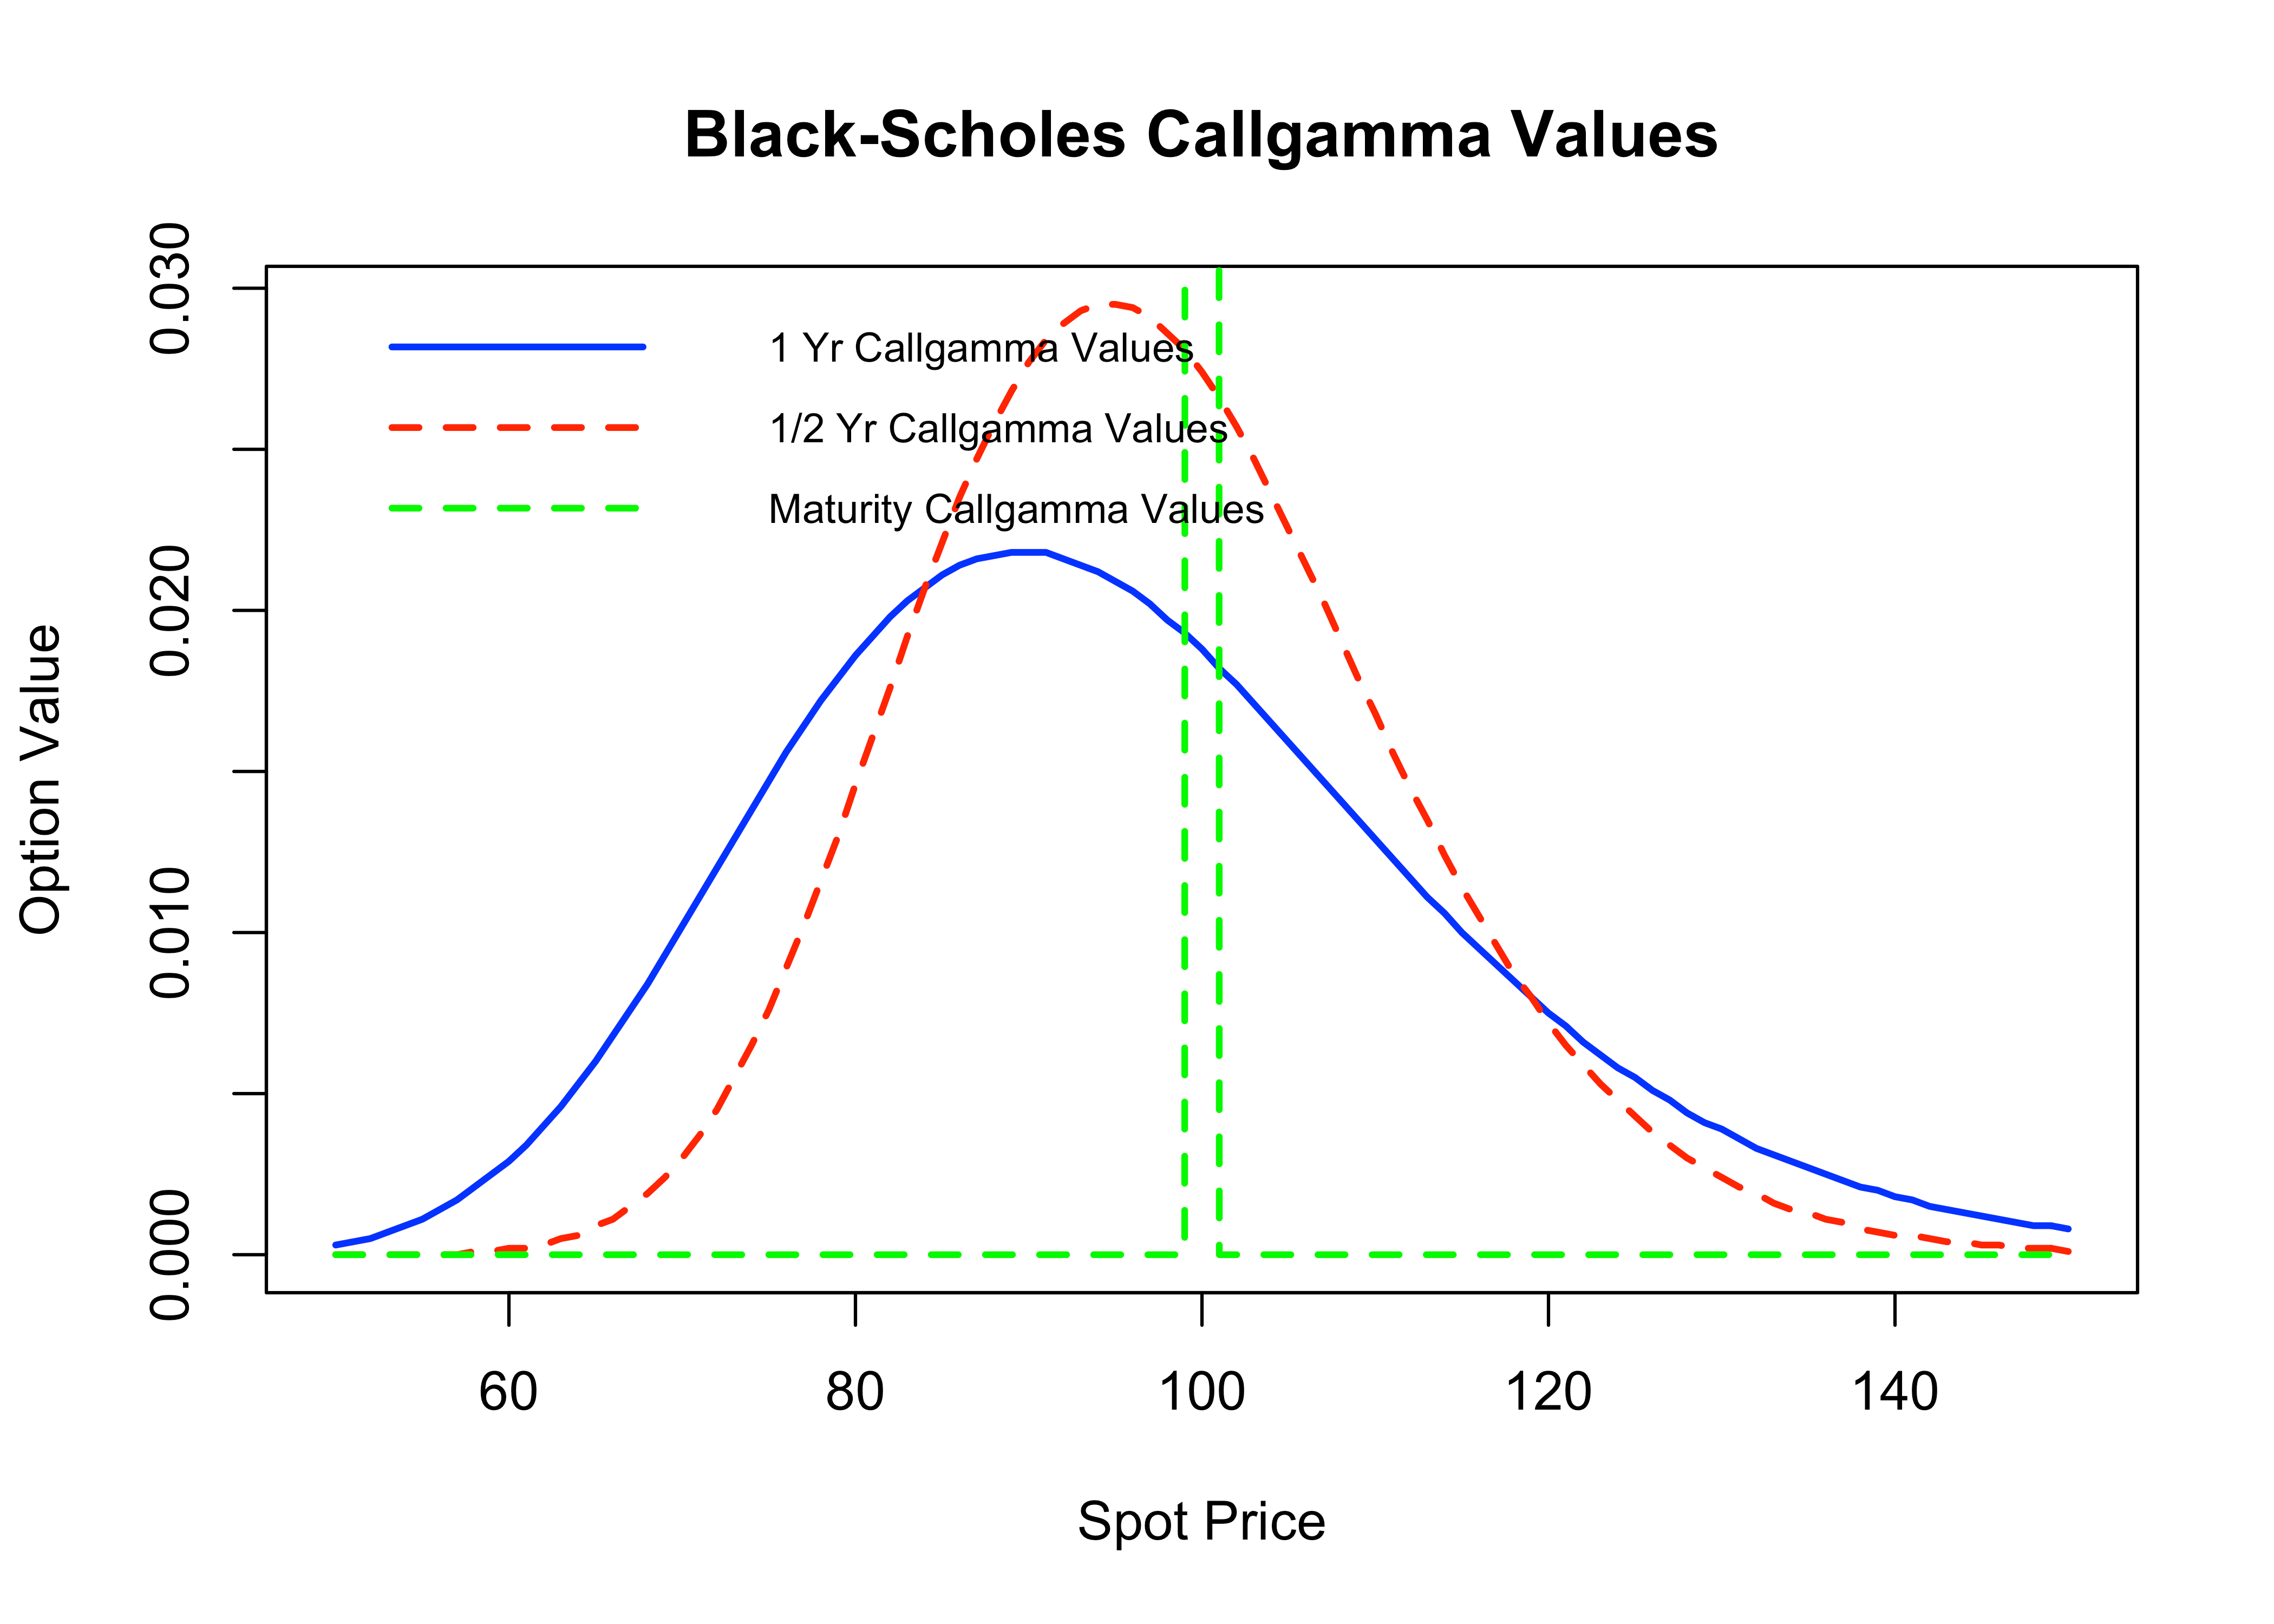

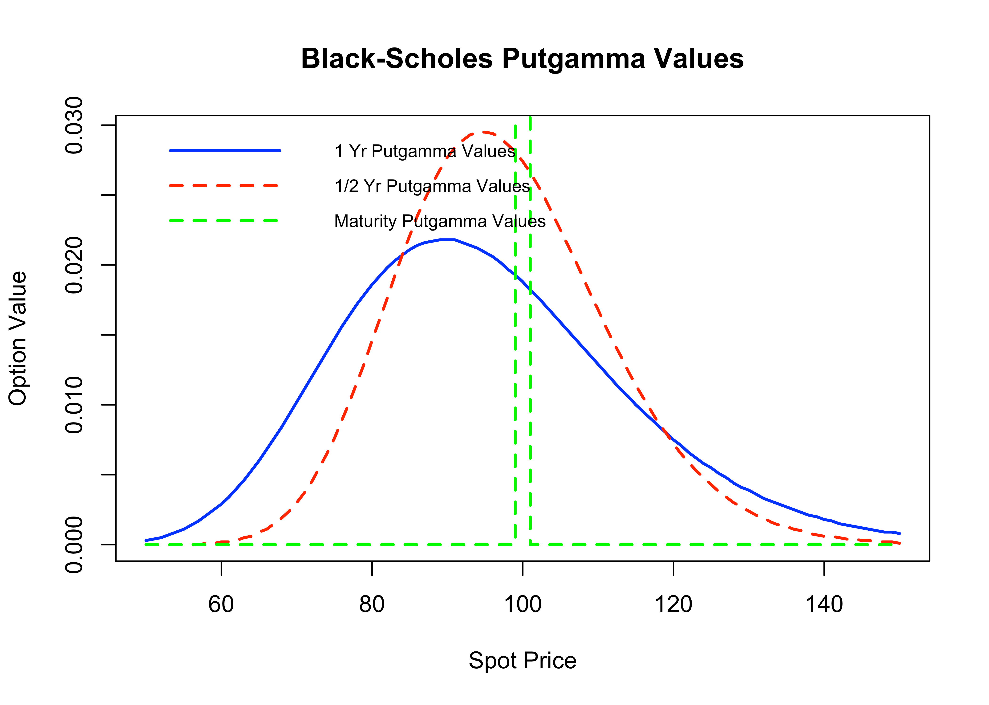

The gamma of an option, , is defined as the rate of change of delta respected to the rate of change of underlying asset price: , where  is the option price and S is the underlying asset price. If spot price is much higher than exercise price, call delta will approaching 1and put delta will approaching 0. If spot price is much lower than the spot price, call delta will approaching 0 and put delta will approaching -1. If the result of losing money or making money becomes pretty sure, the delta will not change a lot when price of underlying asset changes, But when the result is uncertain, especially when the spot price near the exercise price, every change in spot price will influence delta a lot. So, for both put and call option, Gamma first increase value, then drop after exercise price. Longer maturity option have higher Gamma value and more sensitive delta to spot price change for more uncertainty.

**Call Vega & Put Vega**

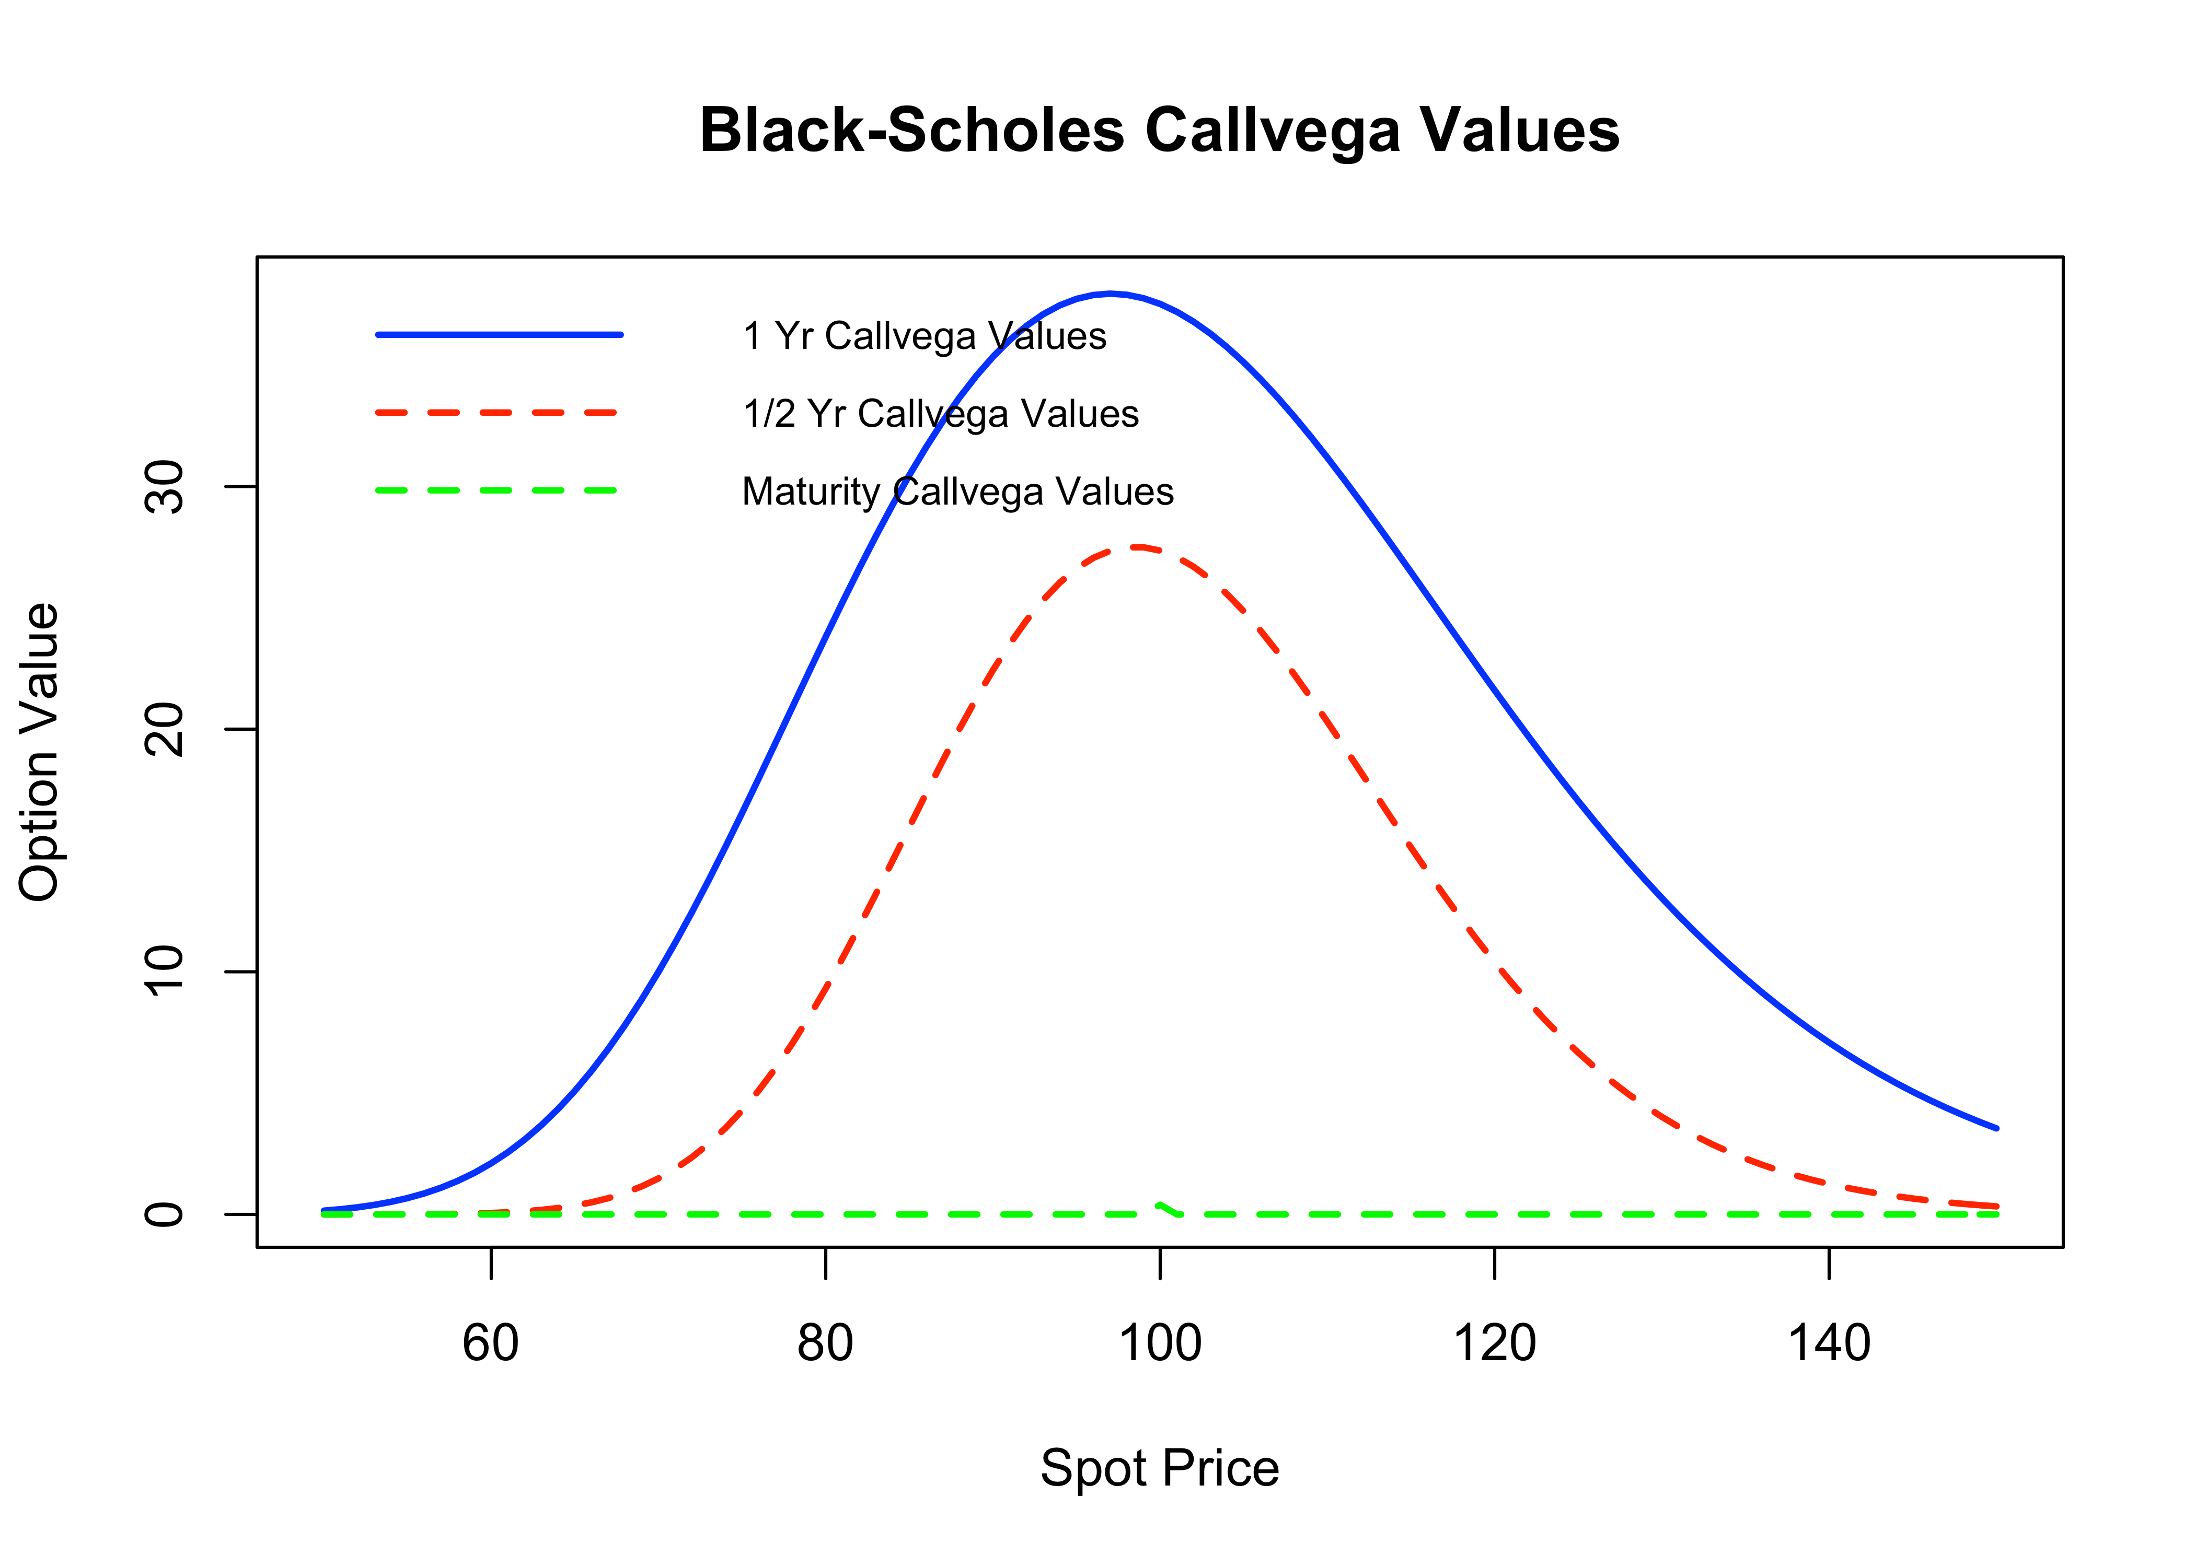

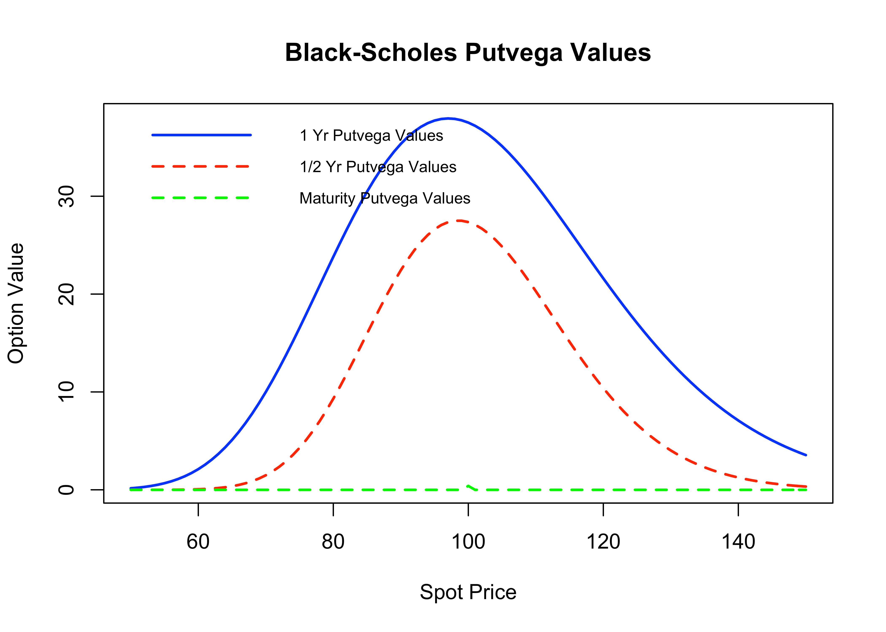

The Vega of an option, ****, is defined as the rate of change of the option price respected to the volatility of the underlying asset: ****, where  is the option price and  is volatility of the stock price. We next show the derivation of Vega for various kinds of stock option.

Option price will increase when the underlying asset price has higher volatility, so Vega value is higher than 0 for both call and put option.

The graph of Vega is similar to that of Gamma: first increase value then drops after reaching exercise price. When it’s uncertain whether the option can exercise or not, the volatility of spot price will influence the option value a lot. But when the result of option is certain (out of money or in the money), the volatility of spot price will not influence option price a lot. When it is very close to maturity, the result of option has already settled, the volatility won’t influence the option value. Longer maturity option has higher value of Vega and the price is more sensitive to spot price volatility because of the uncertainty.

**Call Theta & Put Theta**

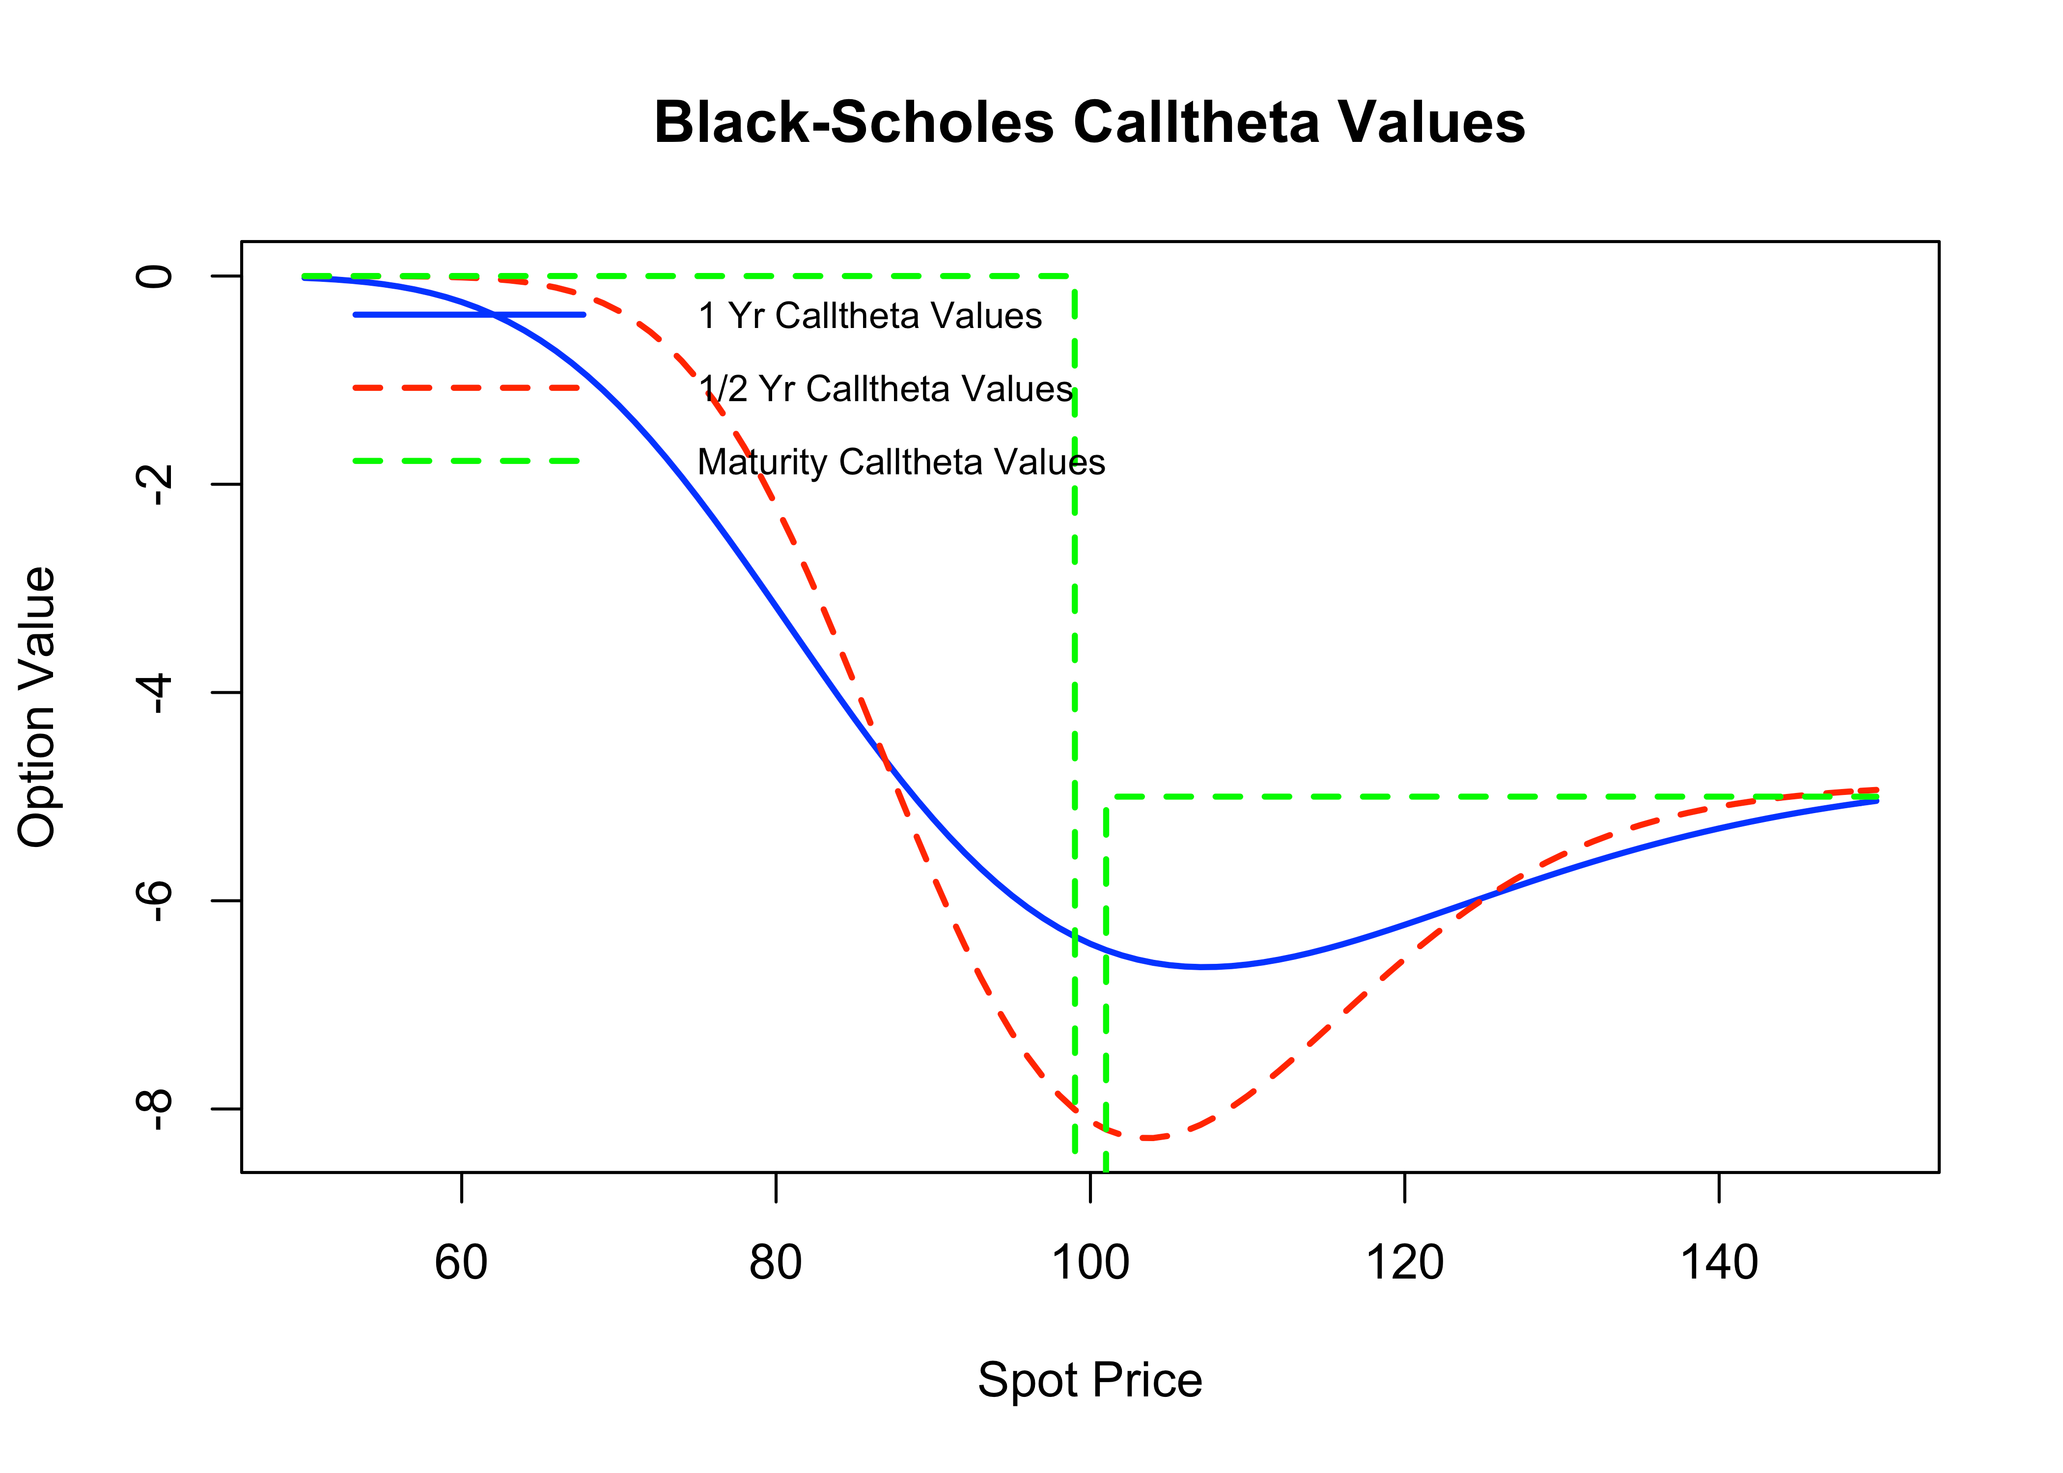

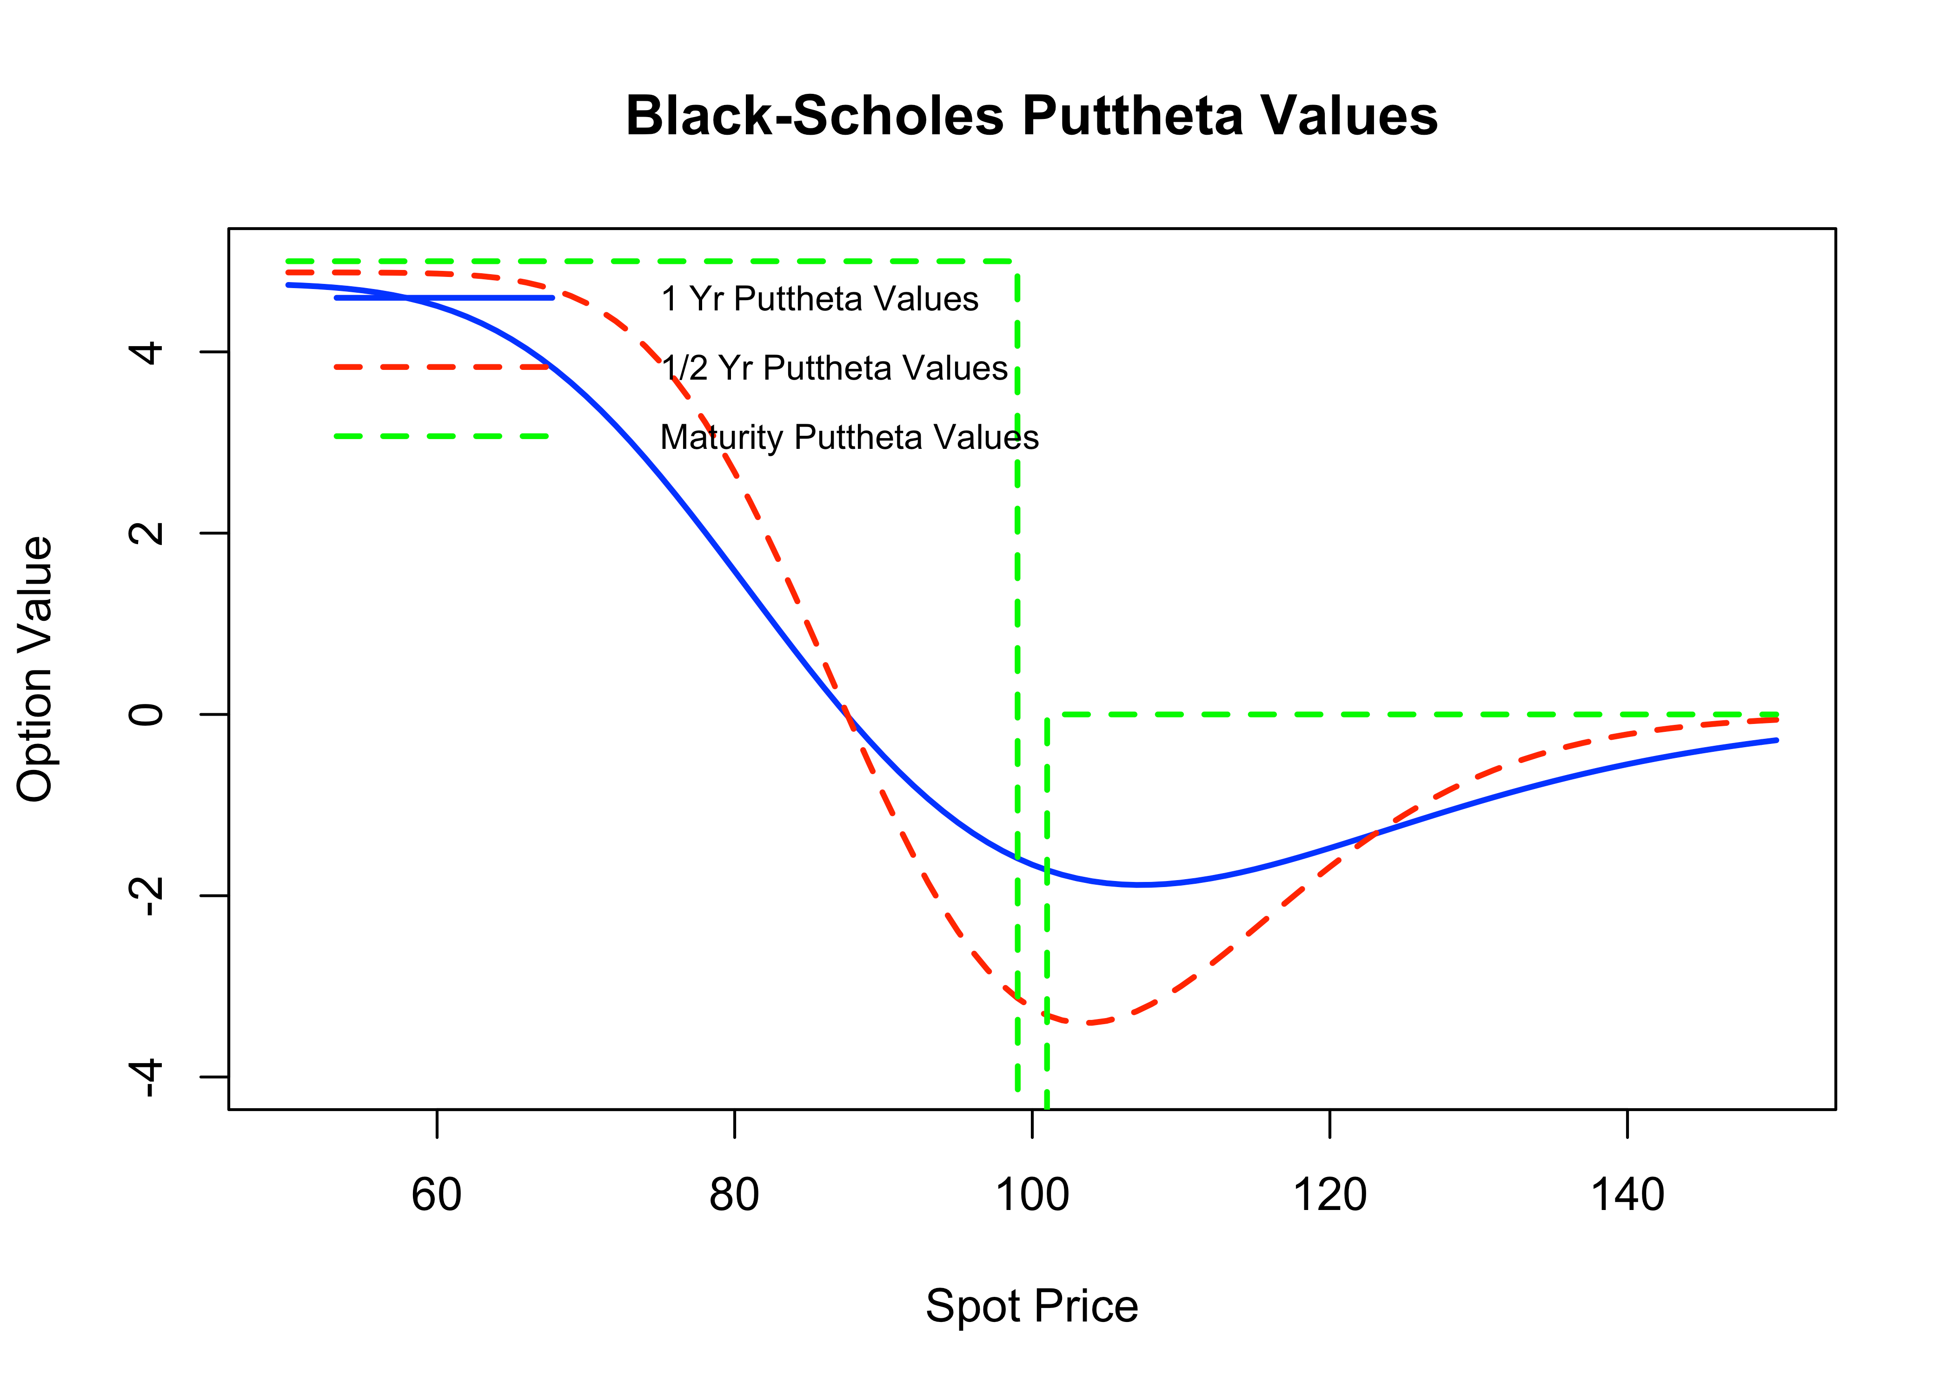

) rf*X*

put)rf*X*

The vega of an option, ****, is defined as the rate of change of the option price respected to the volatility of the underlying asset,  where  is the option price and  is volatility of the stock price. We next show the derivation of vega for various kinds of stock option.

Both graphs first decrease and then reverse at exercise price. Call options often have higher price and their theta is higher because more time cost. Option’s time value decreases with time passes, so typically Theta is a negative number. But for some put option Theta can be positive because when spot price is much lower than exercise price, put option have better chance to make money. For call option, Theta is always negative because it is losing the opportunity to get better price. Both put and call option’s Theta reach lowest point at exercise price, it means option lose time value fastest when the exercise of option is uncertain.

**Call Rho & Put Rho**

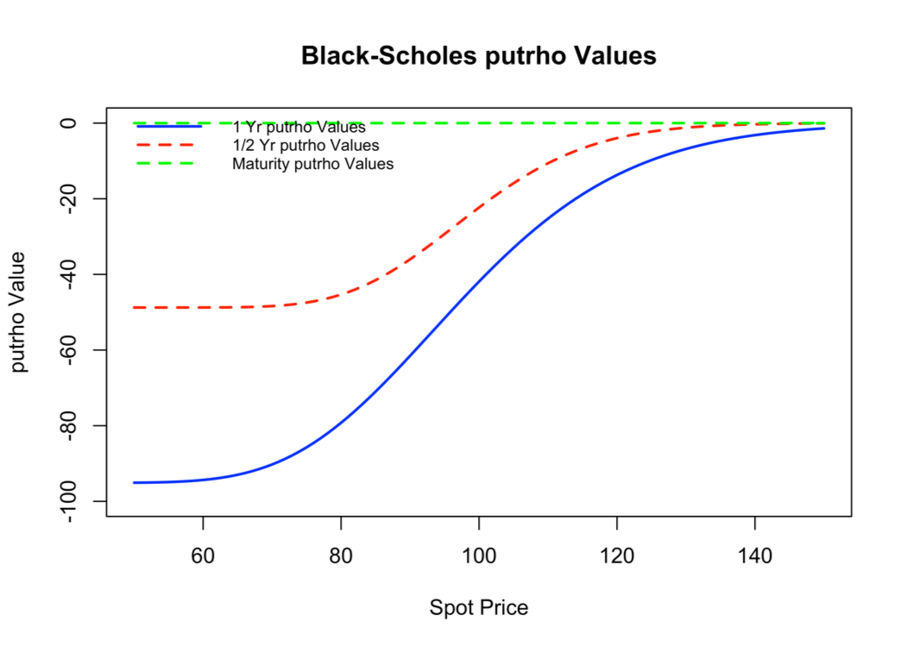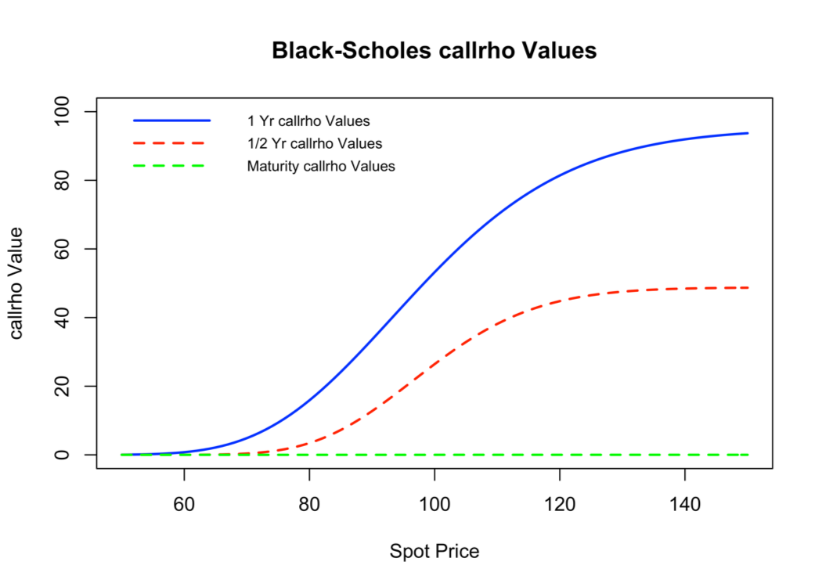

The rho of an option is defined as the rate of change of the option price respected to the interest rate, **,** where  is the option price and ris interest rate. The rho for an ordinary stock call option should be positive because higher interest rate reduces the present value of the strike price which in turn increases the value of the call option. Similarly, the rho of an ordinary put option should be negative by the same reasoning.

The figure of call rho showing that the sensitivity to the interest rate is higher when the T is longer. When the T is smaller and the stock price is higher, the curve presents more smoothly which means that the impact of stock price on the call rho is much smaller.

In graph of put rho, the put option value will change more when the rise in the means that when one-unit of risk-free interest rate rises. The higher the stock price is, the lower the absolute of put rho will be. Further, the sensitivity to the interest rate is higher with a longer T. The closer the maturity date, the smaller the impact of the stock price on the put rho.

**Code:**

# Option Pricing Example

# Include package to connect to Excel

install.packages("openxlsx")

library(openxlsx)

# Path, file, sheet names

Excel_file_path <- "/Users/kunboyao/Downloads/GWU_Fin6281_Assignment_1_2018/"

Excel_file_name <- "Black_Scholes.xlsx"

Excel_full_file_name <- paste(Excel_file_path,Excel_file_name,sep="")

Excel_data_sheet_name <- "Output Data"

Excel_graphs_sheet_name <- "Graphs"

# Load the workbook object once to prevent plots showing up as blanks

Excel_workbook <- openxlsx::loadWorkbook(Excel_full_file_name)

# Number of digits for results

options(digits=8)

# Black-Scholes Option

BlackScholes <- function(S, X, rf, d, T, sigma, flag) {

# d1 and d2 values

F <- S * exp((rf - d)*T)

d1 <- (log(F/X) + (.5*(sigma^2) * T))/(sigma * sqrt(T))

d2 <- (log(F/X) - (.5*(sigma^2) * T))/(sigma * sqrt(T))

# European call and put values and Greeks

call <- exp(-rf * T) * (F * pnorm(d1) - X * pnorm(d2))

put <- exp(-rf * T) * (X * pnorm(-d2) - F * pnorm(-d1))

calldelta <- exp(-d * T) * pnorm(d1)

putdelta <- exp(-d * T) * (pnorm(d1)-1)

callgamma = putgamma = exp(-d * T) * dnorm(d1)/ (S * sqrt(T) * sigma)

callvega = putvega = S * exp(-d * T) * dnorm(d1) *sqrt (T)

callTheta = d*S*exp(-d * T)*pnorm(d1) - (S*exp(-d * T)*dnorm(d1)*sigma/(2*sqrt(T))) - rf*X*exp(-rf * T)*pnorm(d2)

putTheta = -d*S*exp(-d * T)*pnorm(-d1) - (S*exp(-d * T)*dnorm(d1)*sigma/(2*sqrt(T))) + rf*X*exp(-rf * T)*pnorm(-d2)

callRho = X*T*exp(-rf * T)*pnorm(d2)

putRho = X*T*exp(-rf * T)*pnorm(-d2)

if(flag=='call'){

return(call)

} else if(flag=='put') {

return(put)

} else if(flag=='calldelta'){

return(calldelta)

} else if(flag=='putdelta'){

return(putdelta)

} else if(flag=='callgamma'){

return(callgamma)

} else if(flag=='putgamma'){

return(putgamma)

} else if(flag=='callvega'){

return(callvega)

} else if(flag=='putvega'){

return(putvega)

} else if(flag=='callTheta'){

return(callTheta)

} else if(flag=='putTheta'){

return(putTheta)

} else if(flag=='callRho'){

return(callRho)

} else if(flag=='putRho'){

return(putRho)

}}

# Sequence of S values to call function followed by inputs and function call

S_sequence <- seq(from = 50, to = 150, by = 1)

X <- 100

rf <- .05

d <- 0

T_one_year <- 1

T_half_year <- 0.5

T_maturity <- .0001

sigma <- .20

cflag <- 'call'

Calls_one_year <- BlackScholes(S_sequence, X, rf, d, T_one_year, sigma, cflag)

Calls_half_year <- BlackScholes(S_sequence, X, rf, d, T_half_year, sigma, cflag)

Calls_maturity <- BlackScholes(S_sequence, X, rf, d, T_maturity, sigma, cflag)

pflag <- 'put'

Puts_one_year <- BlackScholes(S_sequence, X, rf, d, T_one_year, sigma, pflag)

Puts_half_year <- BlackScholes(S_sequence, X, rf, d, T_half_year, sigma, pflag)

Puts_maturity <- BlackScholes(S_sequence, X, rf, d, T_maturity, sigma, pflag)

cdeltaflag <- 'calldelta'

cdelta_one_year <- BlackScholes(S_sequence, X, rf, d, T_one_year, sigma, cdeltaflag)

cdelta_half_year <- BlackScholes(S_sequence, X, rf, d, T_half_year, sigma, cdeltaflag)

cdelta_maturity <- BlackScholes(S_sequence, X, rf, d, T_maturity, sigma, cdeltaflag)

pdeltaflag <- 'putdelta'

pdelta_one_year <- BlackScholes(S_sequence, X, rf, d, T_one_year, sigma, pdeltaflag)

pdelta_half_year <- BlackScholes(S_sequence, X, rf, d, T_half_year, sigma, pdeltaflag)

pdelta_maturity <- BlackScholes(S_sequence, X, rf, d, T_maturity, sigma, pdeltaflag)

cgammaflag <- 'callgamma'

cgamma_one_year <- BlackScholes(S_sequence, X, rf, d, T_one_year, sigma, cgammaflag)

cgamma_half_year <- BlackScholes(S_sequence, X, rf, d, T_half_year, sigma, cgammaflag)

cgamma_maturity <- BlackScholes(S_sequence, X, rf, d, T_maturity, sigma, cgammaflag)

pgammaflag <- 'putgamma'

pgamma_one_year <- BlackScholes(S_sequence, X, rf, d, T_one_year, sigma, pgammaflag)

pgamma_half_year <- BlackScholes(S_sequence, X, rf, d, T_half_year, sigma, pgammaflag)

pgamma_maturity <- BlackScholes(S_sequence, X, rf, d, T_maturity, sigma, pgammaflag)

cvegaflag <- 'callvega'

cvega_one_year <- BlackScholes(S_sequence, X, rf, d, T_one_year, sigma, cvegaflag)

cvega_half_year <- BlackScholes(S_sequence, X, rf, d, T_half_year, sigma, cvegaflag)

cvega_maturity <- BlackScholes(S_sequence, X, rf, d, T_maturity, sigma, cvegaflag)

pvegaflag <- 'putvega'

pvega_one_year <- BlackScholes(S_sequence, X, rf, d, T_one_year, sigma, pvegaflag)

pvega_half_year <- BlackScholes(S_sequence, X, rf, d, T_half_year, sigma, pvegaflag)

pvega_maturity <- BlackScholes(S_sequence, X, rf, d, T_maturity, sigma, pvegaflag)

cThetaflag <- 'callTheta'

cTheta_one_year <- BlackScholes(S_sequence, X, rf, d, T_one_year, sigma, cThetaflag)

cTheta_half_year <- BlackScholes(S_sequence, X, rf, d, T_half_year, sigma, cThetaflag)

cTheta_maturity <- BlackScholes(S_sequence, X, rf, d, T_maturity, sigma, cThetaflag)

pThetaflag <- 'putTheta'

pTheta_one_year <- BlackScholes(S_sequence, X, rf, d, T_one_year, sigma, pThetaflag)

pTheta_half_year <- BlackScholes(S_sequence, X, rf, d, T_half_year, sigma, pThetaflag)

pTheta_maturity <- BlackScholes(S_sequence, X, rf, d, T_maturity, sigma, pThetaflag)

cRhoflag <- 'callRho'

cRho_one_year <- BlackScholes(S_sequence, X, rf, d, T_one_year, sigma, cRhoflag)

cRho_half_year <- BlackScholes(S_sequence, X, rf, d, T_half_year, sigma, cRhoflag)

cRho_maturity <- BlackScholes(S_sequence, X, rf, d, T_maturity, sigma, cRhoflag)

pRhoflag <- 'putRho'

pRho_one_year <- BlackScholes(S_sequence, X, rf, d, T_one_year, sigma, pRhoflag)

pRho_half_year <- BlackScholes(S_sequence, X, rf, d, T_half_year, sigma, pRhoflag)

pRho_maturity <- BlackScholes(S_sequence, X, rf, d, T_maturity, sigma, pRhoflag)

# Write results to spreadsheet

openxlsx::writeData(Excel_workbook, Excel_data_sheet_name, Calls_one_year, startCol=2, startRow = 2, colNames=FALSE,

rowNames=FALSE, keepNA = TRUE)

openxlsx::writeData(Excel_workbook, Excel_data_sheet_name, Calls_half_year, startCol=3, startRow = 2, colNames=FALSE,

rowNames=FALSE, keepNA = TRUE)

openxlsx::writeData(Excel_workbook, Excel_data_sheet_name, Calls_maturity, startCol=4, startRow = 2, colNames=FALSE,

rowNames=FALSE, keepNA = TRUE)

openxlsx::writeData(Excel_workbook, Excel_data_sheet_name, Puts_one_year, startCol=5, startRow = 2, colNames=FALSE,

rowNames=FALSE, keepNA = TRUE)

openxlsx::writeData(Excel_workbook, Excel_data_sheet_name, Puts_half_year, startCol=6, startRow = 2, colNames=FALSE,

rowNames=FALSE, keepNA = TRUE)

openxlsx::writeData(Excel_workbook, Excel_data_sheet_name, Puts_maturity, startCol=7, startRow = 2, colNames=FALSE,

rowNames=FALSE, keepNA = TRUE)

openxlsx::writeData(Excel_workbook, Excel_data_sheet_name, cdelta_one_year, startCol=8, startRow = 2, colNames=FALSE,

rowNames=FALSE, keepNA = TRUE)

openxlsx::writeData(Excel_workbook, Excel_data_sheet_name, cdelta_half_year, startCol=9, startRow = 2, colNames=FALSE,

rowNames=FALSE, keepNA = TRUE)

openxlsx::writeData(Excel_workbook, Excel_data_sheet_name, cdelta_maturity, startCol=10, startRow = 2, colNames=FALSE,

rowNames=FALSE, keepNA = TRUE)

openxlsx::writeData(Excel_workbook, Excel_data_sheet_name, pdelta_one_year, startCol=11, startRow = 2, colNames=FALSE,

rowNames=FALSE, keepNA = TRUE)

openxlsx::writeData(Excel_workbook, Excel_data_sheet_name, pdelta_half_year, startCol=12, startRow = 2, colNames=FALSE,

rowNames=FALSE, keepNA = TRUE)

openxlsx::writeData(Excel_workbook, Excel_data_sheet_name, pdelta_maturity, startCol=13, startRow = 2, colNames=FALSE,

rowNames=FALSE, keepNA = TRUE)

openxlsx::writeData(Excel_workbook, Excel_data_sheet_name, cgamma_one_year, startCol=14, startRow = 2, colNames=FALSE,

rowNames=FALSE, keepNA = TRUE)

openxlsx::writeData(Excel_workbook, Excel_data_sheet_name, cgamma_half_year, startCol=15, startRow = 2, colNames=FALSE,

rowNames=FALSE, keepNA = TRUE)

openxlsx::writeData(Excel_workbook, Excel_data_sheet_name, cgamma_maturity, startCol=16, startRow = 2, colNames=FALSE,

rowNames=FALSE, keepNA = TRUE)

openxlsx::writeData(Excel_workbook, Excel_data_sheet_name, pgamma_one_year, startCol=17, startRow = 2, colNames=FALSE,

rowNames=FALSE, keepNA = TRUE)

openxlsx::writeData(Excel_workbook, Excel_data_sheet_name, pgamma_half_year, startCol=18, startRow = 2, colNames=FALSE,

rowNames=FALSE, keepNA = TRUE)

openxlsx::writeData(Excel_workbook, Excel_data_sheet_name, pgamma_maturity, startCol=19, startRow = 2, colNames=FALSE,

rowNames=FALSE, keepNA = TRUE)

openxlsx::writeData(Excel_workbook, Excel_data_sheet_name, cvega_one_year, startCol=20, startRow = 2, colNames=FALSE,

rowNames=FALSE, keepNA = TRUE)

openxlsx::writeData(Excel_workbook, Excel_data_sheet_name, cvega_half_year, startCol=21, startRow = 2, colNames=FALSE,

rowNames=FALSE, keepNA = TRUE)

openxlsx::writeData(Excel_workbook, Excel_data_sheet_name, cvega_maturity, startCol=22, startRow = 2, colNames=FALSE,

rowNames=FALSE, keepNA = TRUE)

openxlsx::writeData(Excel_workbook, Excel_data_sheet_name, pvega_one_year, startCol=23, startRow = 2, colNames=FALSE,

rowNames=FALSE, keepNA = TRUE)

openxlsx::writeData(Excel_workbook, Excel_data_sheet_name, pvega_half_year, startCol=24, startRow = 2, colNames=FALSE,

rowNames=FALSE, keepNA = TRUE)

openxlsx::writeData(Excel_workbook, Excel_data_sheet_name, pvega_maturity, startCol=25, startRow = 2, colNames=FALSE,

rowNames=FALSE, keepNA = TRUE)

openxlsx::writeData(Excel_workbook, Excel_data_sheet_name, cTheta_one_year, startCol=26, startRow = 2, colNames=FALSE,

rowNames=FALSE, keepNA = TRUE)

openxlsx::writeData(Excel_workbook, Excel_data_sheet_name, cTheta_half_year, startCol=27, startRow = 2, colNames=FALSE,

rowNames=FALSE, keepNA = TRUE)

openxlsx::writeData(Excel_workbook, Excel_data_sheet_name, cTheta_maturity, startCol=28, startRow = 2, colNames=FALSE,

rowNames=FALSE, keepNA = TRUE)

openxlsx::writeData(Excel_workbook, Excel_data_sheet_name, pTheta_one_year, startCol=29, startRow = 2, colNames=FALSE,

rowNames=FALSE, keepNA = TRUE)

openxlsx::writeData(Excel_workbook, Excel_data_sheet_name, pTheta_half_year, startCol=30, startRow = 2, colNames=FALSE,

rowNames=FALSE, keepNA = TRUE)

openxlsx::writeData(Excel_workbook, Excel_data_sheet_name, pTheta_maturity, startCol=31, startRow = 2, colNames=FALSE,

rowNames=FALSE, keepNA = TRUE)

openxlsx::writeData(Excel_workbook, Excel_data_sheet_name, cRho_one_year, startCol=32, startRow = 2, colNames=FALSE,

rowNames=FALSE, keepNA = TRUE)

openxlsx::writeData(Excel_workbook, Excel_data_sheet_name, cRho_half_year, startCol=33, startRow = 2, colNames=FALSE,

rowNames=FALSE, keepNA = TRUE)

openxlsx::writeData(Excel_workbook, Excel_data_sheet_name, cRho_maturity, startCol=34, startRow = 2, colNames=FALSE,

rowNames=FALSE, keepNA = TRUE)

openxlsx::writeData(Excel_workbook, Excel_data_sheet_name, pRho_one_year, startCol=35, startRow = 2, colNames=FALSE,

rowNames=FALSE, keepNA = TRUE)

openxlsx::writeData(Excel_workbook, Excel_data_sheet_name, pRho_half_year, startCol=36, startRow = 2, colNames=FALSE,

rowNames=FALSE, keepNA = TRUE)

openxlsx::writeData(Excel_workbook, Excel_data_sheet_name, pRho_maturity, startCol=37, startRow = 2, colNames=FALSE,

rowNames=FALSE, keepNA = TRUE)

# Create plot which we will save to spreadsheet

Calls <- plot(x = S_sequence, y = Calls_one_year, main = "Black-Scholes Call Values", xlab = "Spot Price",

ylab = "Option Value", xlim = c(50,150), ylim = c(0, max(Calls_one_year)), type = "l", col = "blue", lwd = 2)

lines(x = S_sequence, y = Calls_half_year, type = "l", col = "red", lwd = 2, lty = 2)

lines(x = S_sequence, y = Calls_maturity, type = "l", col = "green", lwd = 2, lty = 2)

legend(x="topleft", legend=c("1 Yr Call Values","1/2 Yr Call Values", "Maturity Call Values"),

bty="n",lty=c(1,2,2), lwd=c(2,2,2), cex=0.75, col=c("blue","red","green"))

Puts <- plot(x = S_sequence, y = Puts_one_year, main = "Black-Scholes Put Values", xlab = "Spot Price",

ylab = "Option Value", xlim = c(50,150), ylim = c(0, max(Puts_one_year)), type = "l", col = "blue", lwd = 2)

lines(x = S_sequence, y = Puts_half_year, type = "l", col = "red", lwd = 2, lty = 2)

lines(x = S_sequence, y = Puts_maturity, type = "l", col = "green", lwd = 2, lty = 2)

legend(x="topleft", legend=c("1 Yr Put Values","1/2 Yr Put Values", "Maturity Put Values"),

bty="n",lty=c(1,2,2), lwd=c(2,2,2), cex=0.75, col=c("blue","red","green"))

cdelta <- plot(x = S_sequence, y = cdelta_one_year, main = "Black-Scholes calldelta Values", xlab = "Spot Price",

ylab = "Call delta", xlim = c(50,150), ylim = c(0, max(cdelta_one_year)), type = "l", col = "blue", lwd = 2)

lines(x = S_sequence, y = cdelta_half_year, type = "l", col = "red", lwd = 2, lty = 2)

lines(x = S_sequence, y = cdelta_maturity, type = "l", col = "green", lwd = 2, lty = 2)

legend(x="topleft", legend=c("1 Yr calldelta Values","1/2 Yr calldelta Values", "Maturity calldelta Values"),

bty="n",lty=c(1,2,2), lwd=c(2,2,2), cex=0.75, col=c("blue","red","green"))

pdelta <- plot(x = S_sequence, y = pdelta_one_year, main = "Black-Scholes putdelta Values", xlab = "Spot Price",

ylab = "Put delta", xlim = c(50,150), type = "l", col = "blue", lwd = 2)

lines(x = S_sequence, y = pdelta_half_year, type = "l", col = "red", lwd = 2, lty = 2)

lines(x = S_sequence, y = pdelta_maturity, type = "l", col = "green", lwd = 2, lty = 2)

legend(x="topleft", legend=c("1 Yr putdelta Values","1/2 Yr putdelta Values", "Maturity putdelta Values"),

bty="n",lty=c(1,2,2), lwd=c(2,2,2), cex=0.75, col=c("blue","red","green"))

cgamma <- plot(x = S_sequence, y = cgamma_one_year, main = "Black-Scholes callgamma Values", xlab = "Spot Price",

ylab = "call gamma", xlim = c(50,150),ylim = c(0, max(cgamma_half_year)), type = "l", col = "blue", lwd = 2)

lines(x = S_sequence, y = cgamma_half_year, type = "l", col = "red", lwd = 2, lty = 2)

lines(x = S_sequence, y = cgamma_maturity, type = "l", col = "green", lwd = 2, lty = 2)

legend(x="topleft", legend=c("1 Yr callgamma Values","1/2 Yr callgamma Values", "Maturity callgamma Values"),

bty="n",lty=c(1,2,2), lwd=c(2,2,2), cex=0.75, col=c("blue","red","green"))

pgamma <- plot(x = S_sequence, y = pgamma_one_year, main = "Black-Scholes putgamma Values", xlab = "Spot Price",

ylab = "put gamma", xlim = c(50,150), ylim = c(0, max(cgamma_half_year)), type = "l", col = "blue", lwd = 2)

lines(x = S_sequence, y = pgamma_half_year, type = "l", col = "red", lwd = 2, lty = 2)

lines(x = S_sequence, y = pgamma_maturity, type = "l", col = "green", lwd = 2, lty = 2)

legend(x="topleft", legend=c("1 Yr putgamma Values","1/2 Yr putgamma Values", "Maturity putgamma Values"),

bty="n",lty=c(1,2,2), lwd=c(2,2,2), cex=0.75, col=c("blue","red","green"))

cvega <- plot(x = S_sequence, y = cvega_one_year, main = "Black-Scholes callvega Values", xlab = "Spot Price",

ylab = "call vega", xlim = c(50,150),ylim = c(0, max(cvega_one_year)), type = "l", col = "blue", lwd = 2)

lines(x = S_sequence, y = cvega_half_year, type = "l", col = "red", lwd = 2, lty = 2)

lines(x = S_sequence, y = cvega_maturity, type = "l", col = "green", lwd = 2, lty = 2)

legend(x="topleft", legend=c("1 Yr callvega Values","1/2 Yr callvega Values", "Maturity callvega Values"),

bty="n",lty=c(1,2,2), lwd=c(2,2,2), cex=0.75, col=c("blue","red","green"))

pvega <- plot(x = S_sequence, y = pvega_one_year, main = "Black-Scholes putvega Values", xlab = "Spot Price",

ylab = "put vega", xlim = c(50,150), ylim = c(0, max(pvega_one_year)), type = "l", col = "blue", lwd = 2)

lines(x = S_sequence, y = pvega_half_year, type = "l", col = "red", lwd = 2, lty = 2)

lines(x = S_sequence, y = pvega_maturity, type = "l", col = "green", lwd = 2, lty = 2)

legend(x="topleft", legend=c("1 Yr putvega Values","1/2 Yr putvega Values", "Maturity putvega Values"),

bty="n",lty=c(1,2,2), lwd=c(2,2,2), cex=0.75, col=c("blue","red","green"))

cTheta <- plot(x = S_sequence, y = cTheta_one_year, main = "Black-Scholes callTheta Values", xlab = "Spot Price",

ylab = "call Theta", xlim = c(50,150),type = "l", col = "blue", lwd = 2)

lines(x = S_sequence, y = cTheta_half_year, type = "l", col = "red", lwd = 2, lty = 2)

lines(x = S_sequence, y = cTheta_maturity, type = "l", col = "green", lwd = 2, lty = 2)

legend(x="topleft", legend=c("1 Yr callTheta Values","1/2 Yr callTheta Values", "Maturity callTheta Values"),

bty="n",lty=c(1,2,2), lwd=c(2,2,2), cex=0.75, col=c("blue","red","green"))

pTheta <- plot(x = S_sequence, y = pTheta_one_year, main = "Black-Scholes putTheta Values", xlab = "Spot Price",

ylab = "put Theta", xlim = c(50,150), type = "l", col = "blue", lwd = 2)

lines(x = S_sequence, y = pTheta_half_year, type = "l", col = "red", lwd = 2, lty = 2)

lines(x = S_sequence, y = pTheta_maturity, type = "l", col = "green", lwd = 2, lty = 2)

legend(x="topleft", legend=c("1 Yr putTheta Values","1/2 Yr putTheta Values", "Maturity putTheta Values"),

bty="n",lty=c(1,2,2), lwd=c(2,2,2), cex=0.75, col=c("blue","red","green"))

cRho <- plot(x = S_sequence, y = cRho_one_year, main = "Black-Scholes callRho Values", xlab = "Spot Price",

ylab = "Call Rho", xlim = c(50,150), ylim = c(0, max(cRho_one_year)), type = "l", col = "blue", lwd = 2)

lines(x = S_sequence, y = cRho_half_year, type = "l", col = "red", lwd = 2, lty = 2)

lines(x = S_sequence, y = cRho_maturity, type = "l", col = "green", lwd = 2, lty = 2)

legend(x="topleft", legend=c("1 Yr callRho Values","1/2 Yr callRho Values", "Maturity callRho Values"),

bty="n",lty=c(1,2,2), lwd=c(2,2,2), cex=0.75, col=c("blue","red","green"))

pRho <- plot(x = S_sequence, y = pRho_one_year, main = "Black-Scholes putRho Values", xlab = "Spot Price",

ylab = "Put Rho", xlim = c(50,150), type = "l", col = "blue", lwd = 2)

lines(x = S_sequence, y = pRho_half_year, type = "l", col = "red", lwd = 2, lty = 2)

lines(x = S_sequence, y = pRho_maturity, type = "l", col = "green", lwd = 2, lty = 2)

legend(x="topleft", legend=c("1 Yr putRho Values","1/2 Yr putRho Values", "Maturity putRho Values"),

bty="n",lty=c(1,2,2), lwd=c(2,2,2), cex=0.75, col=c("blue","red","green"))

# Print pic to view and insertPlot into Excel

print(Calls)

openxlsx::insertPlot(Excel_workbook,sheet=Excel_graphs_sheet_name,width=7,height=5,startRow=2,startCol=2,fileType="bmp",units="in",dpi=600)

print(Puts)

openxlsx::insertPlot(Excel_workbook,sheet=Excel_graphs_sheet_name,width=7,height=5,startRow=2,startCol=2,fileType="bmp",units="in",dpi=600)

print(cdelta)

openxlsx::insertPlot(Excel_workbook,sheet=Excel_graphs_sheet_name,width=7,height=5,startRow=2,startCol=2,fileType="bmp",units="in",dpi=600)

print(pdelta)

openxlsx::insertPlot(Excel_workbook,sheet=Excel_graphs_sheet_name,width=7,height=5,startRow=2,startCol=2,fileType="bmp",units="in",dpi=600)

print(cgamma)

openxlsx::insertPlot(Excel_workbook,sheet=Excel_graphs_sheet_name,width=7,height=5,startRow=2,startCol=2,fileType="bmp",units="in",dpi=600)

print(pgamma)

openxlsx::insertPlot(Excel_workbook,sheet=Excel_graphs_sheet_name,width=7,height=5,startRow=2,startCol=2,fileType="bmp",units="in",dpi=600)

print(cvega)

openxlsx::insertPlot(Excel_workbook,sheet=Excel_graphs_sheet_name,width=7,height=5,startRow=2,startCol=2,fileType="bmp",units="in",dpi=600)

print(pvega)

openxlsx::insertPlot(Excel_workbook,sheet=Excel_graphs_sheet_name,width=7,height=5,startRow=2,startCol=2,fileType="bmp",units="in",dpi=600)

print(cTheta)

openxlsx::insertPlot(Excel_workbook,sheet=Excel_graphs_sheet_name,width=7,height=5,startRow=2,startCol=2,fileType="bmp",units="in",dpi=600)

print(pTheta)

openxlsx::insertPlot(Excel_workbook,sheet=Excel_graphs_sheet_name,width=7,height=5,startRow=2,startCol=2,fileType="bmp",units="in",dpi=600)

print(cRho)

openxlsx::insertPlot(Excel_workbook,sheet=Excel_graphs_sheet_name,width=7,height=5,startRow=2,startCol=2,fileType="bmp",units="in",dpi=600)

print(pRho)

openxlsx::insertPlot(Excel_workbook,sheet=Excel_graphs_sheet_name,width=7,height=5,startRow=2,startCol=2,fileType="bmp",units="in",dpi=600)

# Save the workbook object exactly once to prevent plots showing up as blanks

openxlsx::saveWorkbook(Excel_workbook,Excel_full_file_name,overwrite=TRUE)